1. Write an equation that expresses the fact that a function f is continuous at the number 4.

$$f(x)=x$$

* $f\left(4\right)$ exists.
* $\lim_{x→4}f\left(x\right)$ exists.
* $\lim_{x→4}{f\left(x\right)}=f\left(4\right)$.

1. If f is continuous on $\left(-∞,∞\right)$, what can be said about its graph?

The graph does not have any holes in it.

1. 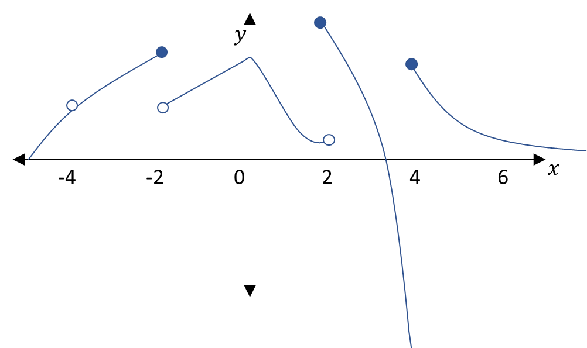Use the graph to the right (Graph 1) to answer the following questions.

Graph 1

1. State the numbers where f is discontinuous and why.
2. For each of those numbers, determine whether f is continuous from the right, left, or neither.

|  |  |  |
| --- | --- | --- |
| Where is it discontinuous | Why is it discontinuous | Continuity direction |
| $$x=-4$$ | Open circle there. | Neither |
| $$x=-2$$ | Closed circle not going right. | Left |
| $$x=2$$ | Closed circle not going left. | Right |
| $$x=4$$ | Closed circle not going left. | Right |

1. 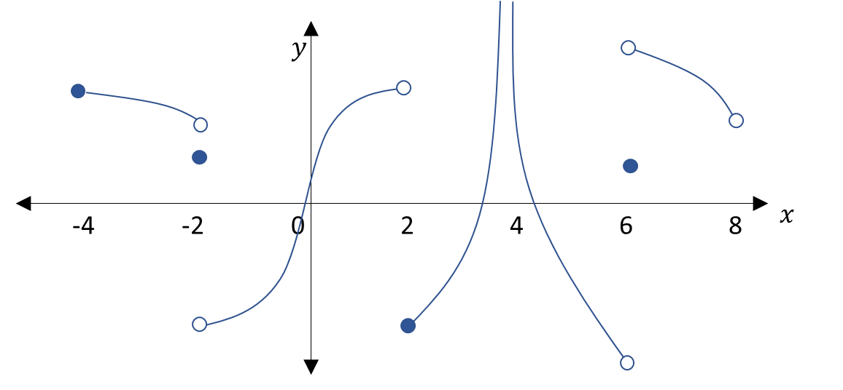Looking at Graph 2, state which intervals are continuous.

Graph 2

$$\left[-4,-2\right)$$

$$\left(-2,2\right)$$

$$\left[2,4\right)$$

$$(4, 6)$$

$$(6, 8)$$

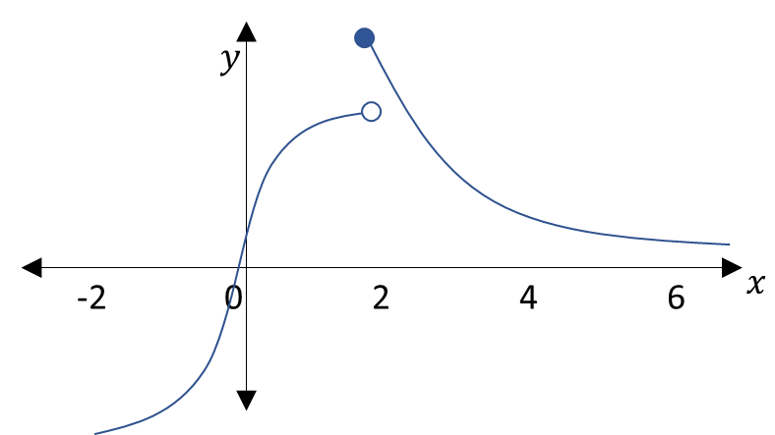

1. Make a graph that’s discontinuous except that it’s continuous from the right at 2 and wherever else possible.

“continuous from the right at 2” 🡺 “graph jumps at 2; the line going to the right from 2 is closed at 2”

(Graph 3)

Graph 3

1. 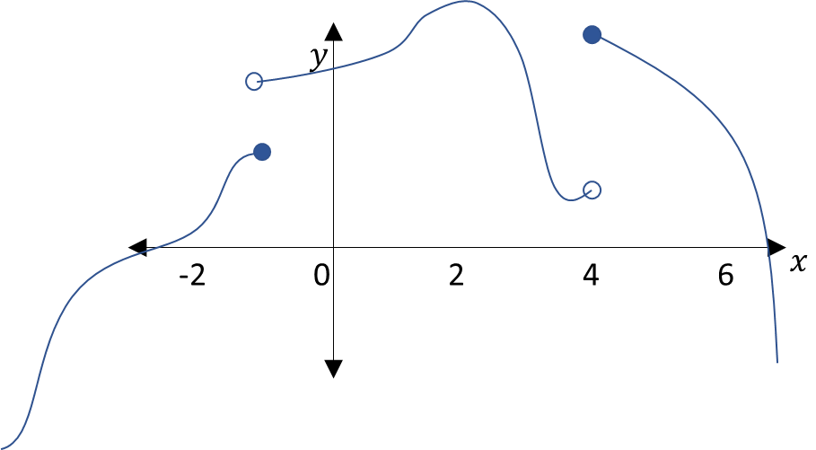Make a graph that’s discontinuous at -1 and 4 except it’s continuous from the left at -1 and form the right at 4 and wherever else possible.

“discontinuous at -1 … continuous from the left at -1” 🡺 “the graph jumps at -1; the line going to the left from -1 had a closed circle at -1”

Graph 4

“discontinuous at…4 … continuous from the right at 4” 🡺 “the graph jumps at 4; the line going to the right from 4 is closed at 4”

(Graph 4)

1. 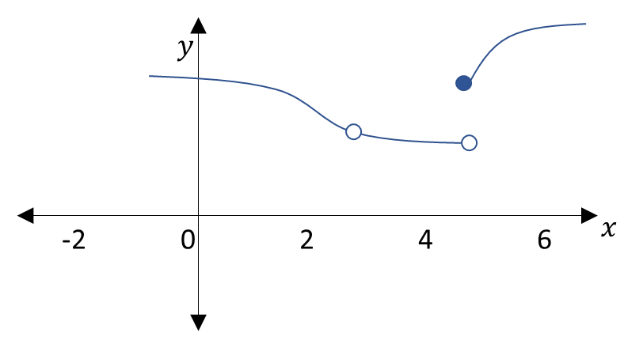Make a graph with removable discontinuity at 3 and jump discontinuity at 5 and continuous wherever else possible.

“removable discontinuity at 3” 🡺 “hole at 3”

“jump discontinuity at 5” 🡺 “graph jumps at 5”

(Graph 5)

Graph 5

1. 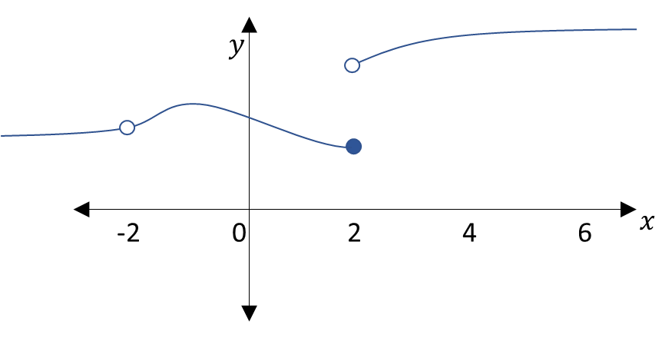Make a graph that’s not continuous from either the left or right at -2, but continuous from the left at 2 and continuous wherever else possible.

“not continuous from either the left or right at -2” 🡺 “hole at -2”

“continuous from the left at 2” 🡺 “graph jumps at 2; the line going left from 2 is closed at 2”

Graph 6

(Graph 6)

1. The toll $T$ charged for driving on a certain stretch of a toll road is $5 except during rush hours (between 7 AM and 10 AM and between 4 PM and 7 PM). At these times, the toll is $7.
2. Graph $T$ over time $t$, where $t$ means hours after midnight.

When $t∈\left[0, 7\right)$, $T=\$5$.

When $t∈\left[7, 10\right)$, $T=\$7$.

When $t∈\left[10, 16\right)$, $T=\$5$.

When $t∈\left[16, 19\right)$, $T=\$7$.

When $t∈\left[19, 24\right)$, $T=\$5$.

b